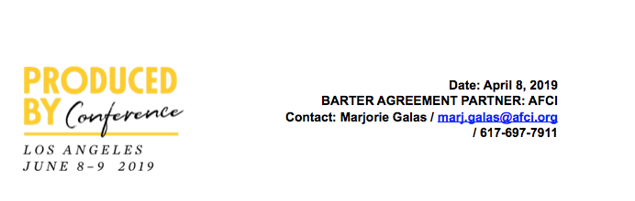

**The Art and Craft of Pitching**

**DEADLINE FOR SUBMISSION: MAY 24, 2019**

PLEASE COMPLETE THIS FORM, INCLUDING YOUR PITCH

SAVE THE DOCUMENT AND SUBMIT AS A PDF FILE

**SUBMISSIONS SHOULD BE SENT TO:** [pbcpitchsession@gmail.com](mailto:pitchpbc@gmail.com)

**THIS FORM MUST BE SUBMITTED ALONG WITH YOUR SIGNED RELEASE**

Full Name: ­­­­­___________________­­­­­________________________

PGA Member Number (if applicable): ______________________

E-Mail: __________________________ Phone Number: ___________________________

Chose One: Film ________ TV ________

You’ll be pitching to Gail Berman (President of the Producers Guild; Chairperson, SIDECAR), Mike Farah (CEO, Funny or Die), James F. Lopez (President, Will Packer Productions; *Little*, *What Men Want*) and Barry Jossen (Head of A+E Studios).

**NOTE**: *Our panelists will NOT be buying pitches. The focus in these sessions is solely on developing this essential pitching skill and learning its finer points via real-time case studies. If selected you will be delivering your pitch in front of a live audience (including press). Please be advised that the treatment that you provide, below, as well as any and all information that you disclose as part of your pitch, if you are selected, are not subject to any confidentiality whatsoever. Please refer to the Release for further details.*

**PITCH**: In 400 words or less please describe the project/idea you wish to pitch to our panel of experienced producers.

**YOUR PITCH, SUBMISSION FORM AND RELEASE FORM NEED TO BE SUBMITTED AT THE SAME TIME.**